|  |  |  |
| --- | --- | --- |
|  | **CMPS 312 Project Phase 2 – Data Layer using Firestore, Firebase Storage and local SQLite Database (10% of the course grade)** | |
| **Group Id:** | | 4 |
| **Group Members:**  Bsmalla Mostafa 202204404  Ahya AlWattar   202204901  Carmela Chavez 202206774  Ganna Soltan  202205763 | | **Emails:**  [bm2204404@qu.edu.qa](mailto:bm2204404@qu.edu.qa)  [ah2204901@qu.edu.qa](mailto:ah2204901@qu.edu.qa)  [cc2206774@qu.edu.qa](mailto:cc2206774@qu.edu.qa)  [gs2205763@qu.edu.qa](mailto:gs2205763@qu.edu.qa) |

# Grading Rubric - In the Functionality column please specify either:

***Working (completed x%)*, *Not Working (completed x%)* or *Not done*.**

|  |  |  |  |  |
| --- | --- | --- | --- | --- |
| Criteria | | % | Functionality* | Quality of the implementation |
| 1. **Database Design:** Firestore database schema diagram and SQLite database schema diagram | | 5% | 100% |  |
| **2) Design and implement** | | **90%** |  |  |
|  | U1 – Signup and Signin using Firebase Authentication | 10 | 100% |  |
| U2 - YalaPay Dashboard | 8 | 100% |  |
| U3 - List/Search/Add/ Update and Delete a customer:  1. List Customers (5 pts)  2. Search Customers (5 pts)  3. Add Customer (5 pts)  4. Update Customer (4 pts)  5. Delete Customer (3 pts) | 22 | 100% |  |
| U4 - List/Search/Add/ Update and Delete an Invoice  1. List Invoices (5 pts)  2. Search Invoices (5 pts)  3. Add Invoice (5 pts)  4. Update Invoice (4 pts)  5. Delete Invoice (3 pts) | 22 | 100% |  |
| U5 - List/Search/Add/ Update and Delete payments for an invoice  1. List Payments (5 pts)  2. Search Payments (5 pts)  3. Add Payment including attach a cheque image (9 pts)  4. Update Payment including attach a cheque image (8 pts)  5. Delete Payment (3 pts) | 30 | 100% |  |
| U6 - Manage Cashing Cheques  1. Add Cheques Deposit (10 pts)  2. List Cheque Deposits (5 pts)  3. Update Cheques Deposit (15 pts) | 30 | 100% |  |
| U7 - Invoices Report | 8 | 100% |  |
| U8 - Cheques Report | 8 | 100% |  |
| **3) Testing documentation** using screen shots illustrating the app testing.  - Discussion of the project contribution of each team member [-10pts if not done] | | 5% | 100% |  |
| **Total** | | 100 |  |  |
| Copying and/or plagiarism or not being able to explain or answer questions about the implementation | | -  100 |  |  |

**\* Possible grading for functionality** - ***Working*** (get 70% of the assigned grade), ***Not*** ***working*** (lose 40% of assigned grade and ***Not done*** (get 0). The remaining grade is assigned to the quality of the implementation.

In case your implementation is not working then 40% of the grade will be lost and the remaining 60% will be determined based on of the code quality and how close your solution to the working implementation.

Solution quality also includes meaningful naming of identifiers (according to Flutter/Dart naming conventions), no redundant code, simple and efficient design, clean implementation without unnecessary files/code, use of comments where necessary, proper code formatting and indentation.

**Marks will be reduced** forcode duplication, poor/inefficient coding practices, poor naming of identifiers, unclean/untidy submission, and unnecessary complex/poor user interface design.

# Database Design

# Firestore database schema diagram

Cheque Deposits Collection

|  |  |
| --- | --- |
| Field Name | Data Type |
| id (unique key) | String |
| bankAccountNo | String |
| cashedDate | String |
| depositDate | String |
| status | String |
| chequeNos | Array (number) |

Cheques Collection

|  |  |
| --- | --- |
| Field Name | Data Type |
| chequeNo (unique key) | number |
| amount | number |
| bankName | String |
| cashedDate | String |
| chequeImageUri | String |
| drawer | String |
| dueDate | String |
| recievedDate | String |
| returnDate | String |
| returnReason | String |
| status | String |

Customers Collection

|  |  |
| --- | --- |
| Field Name | Data Type |
| id (unique key) | String |
| address | map |
| * city | String |
| * country | String |
| * street | String |
| companyName | String |
| companyNameLower | String |
| contactDetails | map |
| * email | String |
| * firstName | String |
| * firstNameLower | String |
| * lastName | String |
| * mobile | String |

Invoices Collection

|  |  |
| --- | --- |
| Field Name | Data Type |
| id (unique key) | String |
| customerId | String |
| customerName | String |
| customerNameArray | Array (String) |
| customerNameLower | String |
| dueDate | String |
| invoiceDate | String |
| amount | number |

Payments Collection

|  |  |
| --- | --- |
| Field Name | Data Type |
| id (unique key) | String |
| amount | number |
| chequeNo | number |
| invoiceNo | String |
| paymentDate | String |
| paymentMode | String |
| paymentModeLower | String |

Users Collection

|  |  |
| --- | --- |
| Field Name | Data Type |
| email (unique key) | String |
| firstName | String |
| lastName | String |

# SQLite database schema diagram

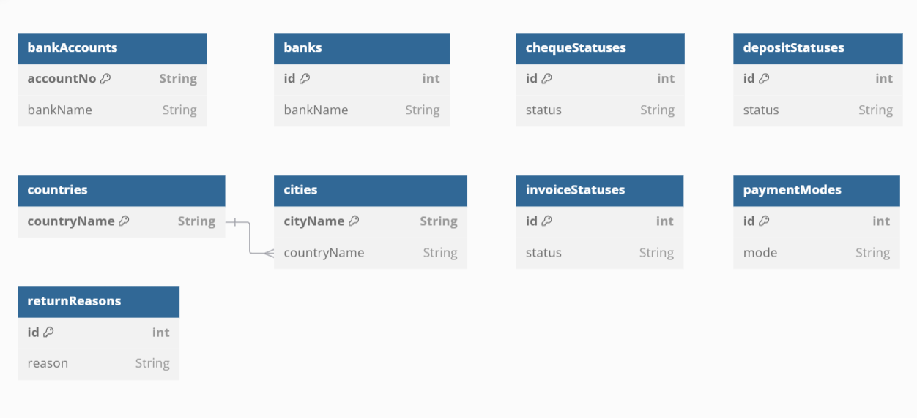

# Testing

# U1 – Signup and Signin using Firebase Authentication

# U2 - YalaPay Dashboard

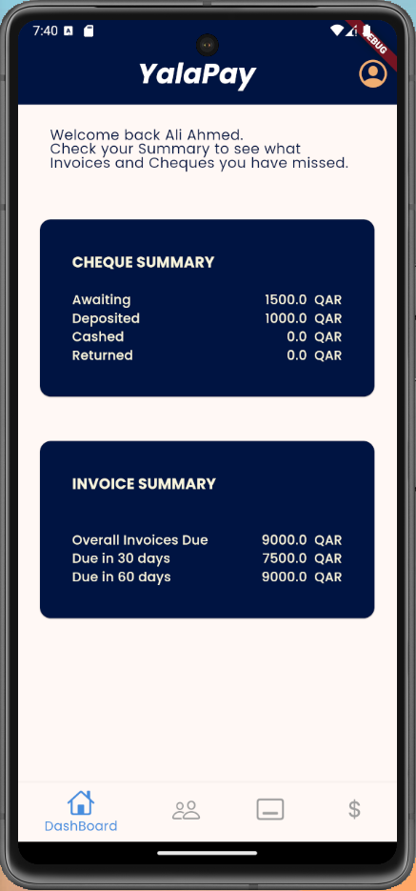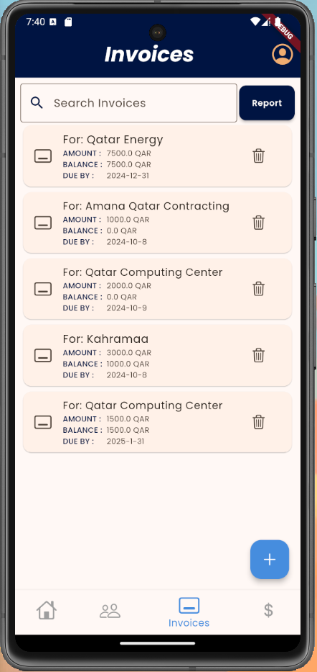

# U3 - List/Search/Add/ Update and Delete a Customer

# List Customers

# Search Customers

1. A screenshot of a phone

   Description automatically generatedA screen shot of a cell phone

   Description automatically generatedA screenshot of a phone

   Description automatically generated

# Add Customer

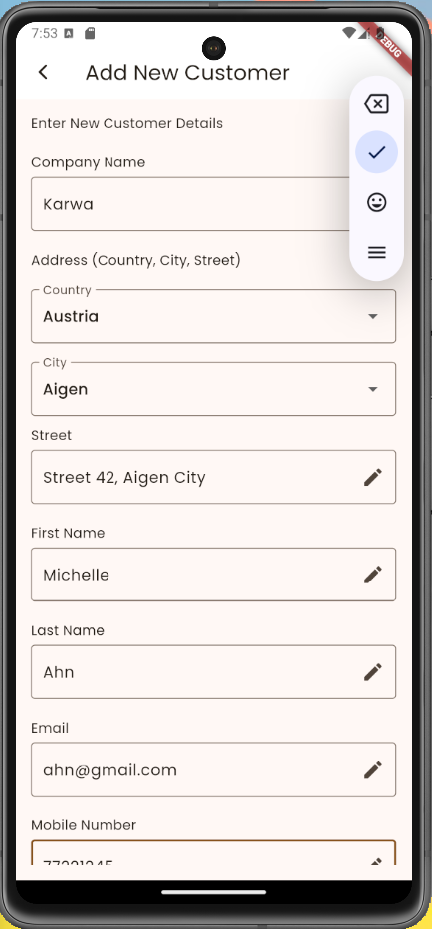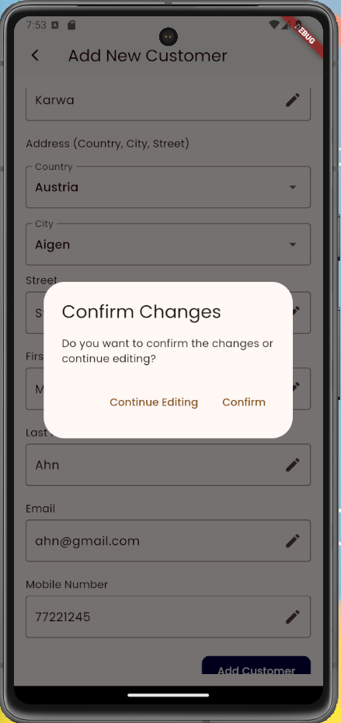

# Update Customer

# Delete Customer

# U4 - List/Search/Add/ Update and Delete an Invoice

# List Invoices

# Search Invoices

# Add Invoice

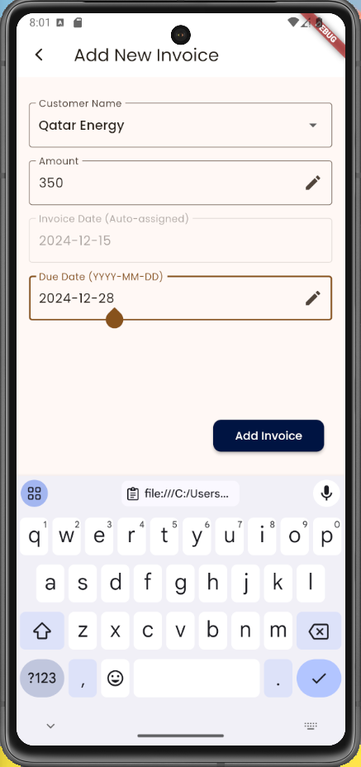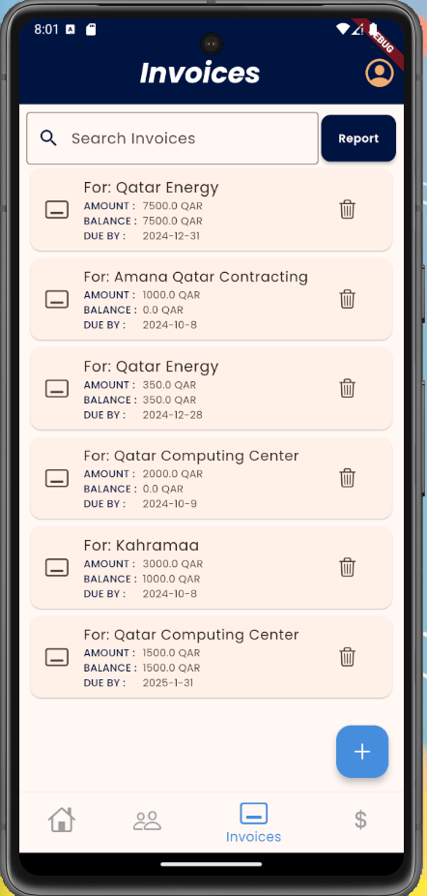

# Update Invoice

# Delete Invoice

# U5 - List/Search/Add/ Update and Delete payments for an invoice

# List Payments

# Search Payments

# Add Payment including attach a cheque image

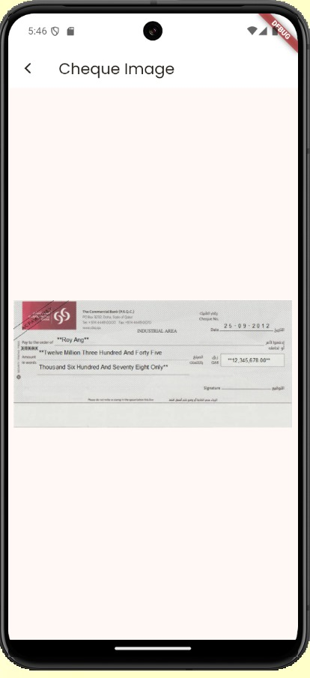

# Update Payment

# U6 - Manage Cashing Cheques

# Add Cheques Deposit

Include the ability to create a Cheque Deposit having multiple cheques.

# List Cheque Deposits

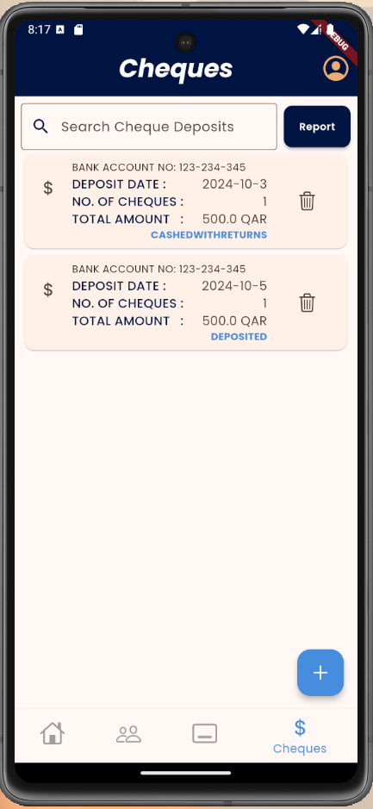

# Update Cheques Deposit

Include the ability to set the *return date* and the *return reason* per cheque.

# U7 - Invoices Report

# U8 - Cheques Report

# Team member contributions

Bsmalla Mostafa

* Invoices Collection, Repository and Provider
* Payments Collection, Repository and Provider
* Firebase Storage for add cheque image with camera

(And any associated widgets and screens)

Ahya AlWattar

* Cheques Collection, Repository and Provider
* Cheque Deposits Collection, Repository and Provider

(And any associated widgets and screens)

Carmela Chavez

* Firebase Authentication; Signin and Signup
* Cheque Reports Filtering
* Dashboard’s Cheque and Invoice Summary

(And any associated widgets and screens)

Ganna Soltan

* Local SQL database initialization
* Customers Collection, Repository and Provider
* Invoice Reports Filtering

(And any associated widgets and screens)